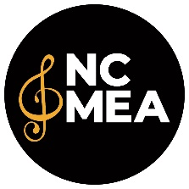
NCMEA Payment and/or Expense Reimbursement Request Form
NCMEA Office: 883 Washington St. Ste. C, Raleigh NC 27605 | sheiserman@ncmea.net

Name ___________________________ ____________________________________
First Last

Home Address _________________________________ ______________________ ________ __________
Street City State Zip

Preferred Phone_________________________Email_____________________________________________

Purpose _________________________________________________________________________________

Receipts are Required for All Expenses

Date  fill in each date here | MM/DD  _______ | MM/DD  _______ | MM/DD  _______ | MM/DD  ________ | MM/DD  ________ | MM/DD  ________ | MM/DD  _______ | Line Total
Breakfast (Max $9.00/day)
Lunch (Max $11.80/day)
Dinner (Max $20.50/day)
Lodging (Max $130.00/day)
Shuttle/Taxi
Airfare
# of Miles
Mileage @ $.55 (multiply # of miles by .55)
Parking
Other ____________
Fees/Honorarium
(W-9 Required)
Totals

Submitter Signature _______________________________________________ Date ___________________
(I certify that all original receipts and reports are attached, as necessary, and that all expenses submitted are for NCMEA activities.) For all student event reimbursements, please return completed form to the event chair for approval.

Authorized by __________________________________________ Date _________________________________

NCMEA Title __________________________________________

Paid by __________________________ Amt. $ _____________ Date __________ Check # _________

