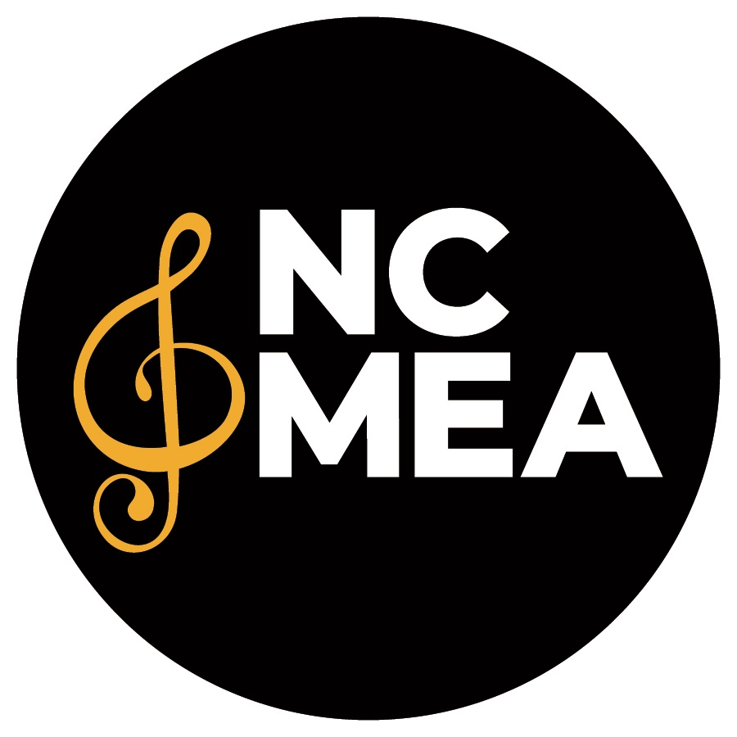INVOICE
North Carolina Music Educators Association
Music Performance Adjudication Plaque Order
Please send one MPA “SUPERIOR RATING” plaque to:

School Name _________________________________________________________________________

Director Name ________________________________________________________________________

Director’s Email Address ________________________________________________________________

School’s Street Address_________________________________________________________________
Street City Zip Code

School’s Phone Number ___________________________

STATEMENT OF ELIGIBILITY

I hereby certify that ________________________________________ □ band □ chorus □ orchestra □ jazz
Performer/Performing Group

__________________________________________ received a "SUPERIOR RATING" in the MPA held
School Name

at _____________________________________________________________ on __________________
Site Date to Include Year

Event Chair's Signature ____________________________________

Director's Signature ________________________________________

**************************
PLEASE NOTE: Schools engrave their plaques once received. Plaque plates are not engraved by NCMEA.

Plaque(s) will be shipped by FedEx.
Be sure that the address listed above is a street address. FedEx cannot deliver to a PO Box.

Plaques cost $100.00 each, which covers NCMEA’s purchase cost plus shipping. Amount enclosed: $_______

Send check payable to NCMEA
Office Use Only

Check # _______________

Deposit Date ___________

Ship Date ______________

with this form to:

NCMEA
Susan Heiserman, Executive Director
883 Washington St., Ste. C
Raleigh, NC 27605

